Political Education in Gen Z

# INTRODUCTION

Our studio theme is Digital Democracy. We have narrowed down our problem domain to political education in Gen Z, a term used for people born from 1996 onwards. Our initial needfinding revealed an interesting tension between young people wanting to know more about politics, but felt as though it was extremely difficult to simplify those news, and instead relied on their parents’ political views to inform their own.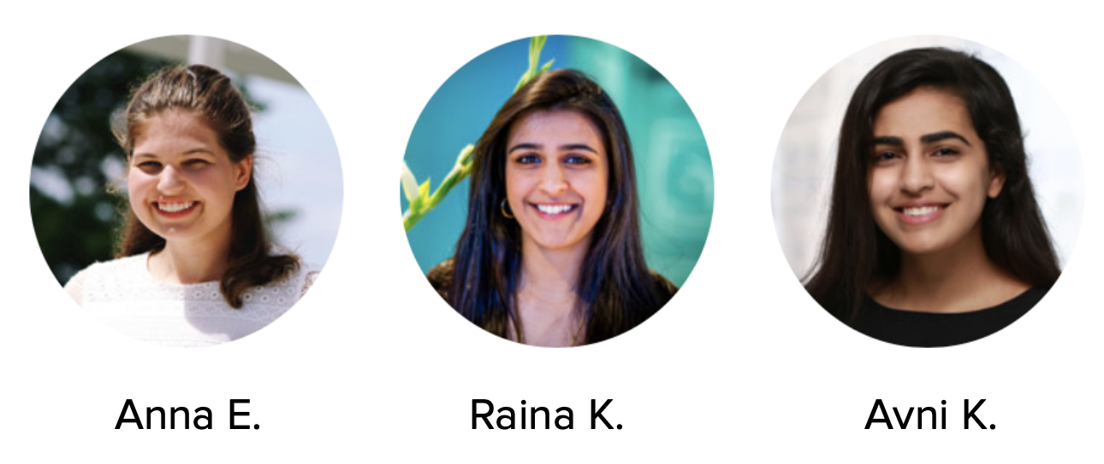

# INITIAL POV

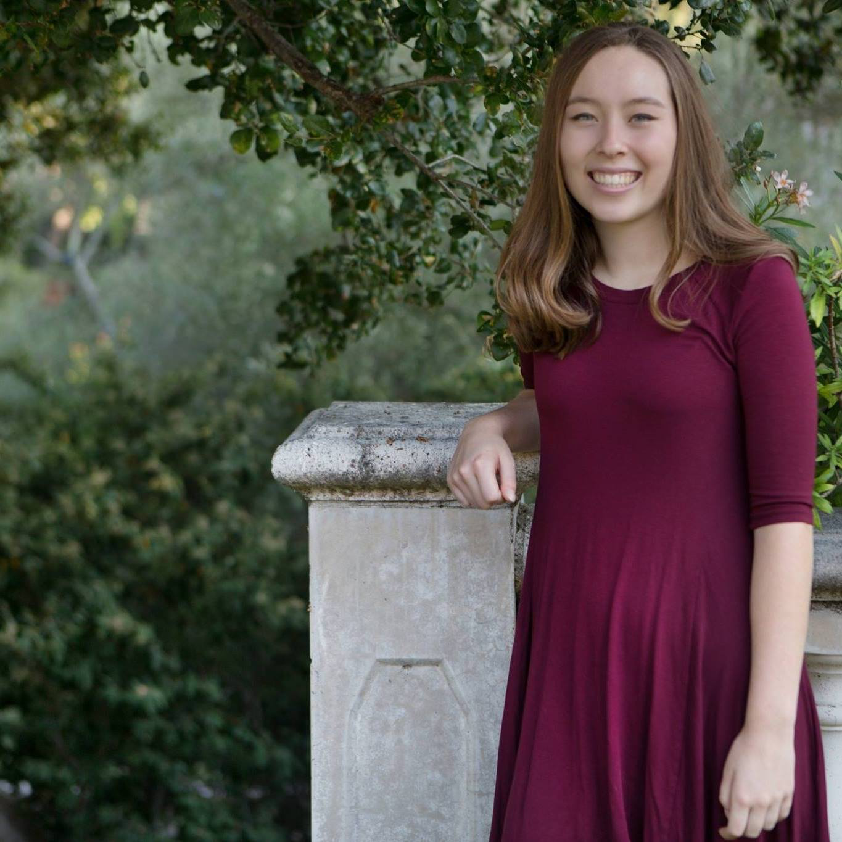

We met Christie, a sophomore at Stanford from Menlo Park, whose father used to be a local politician, but does not consider herself politically engaged. We were amazed to realize that she relies on her parents to tell her who to vote for. It would be game-changing to empower young and first-time voters to make their own decisions on who to vote for.

# ADDITIONAL NEEDFINDING

Based on our four initial interviews, we identified needs for earlier political education and engagement, and empowerment of young voters. This week, we conducted three additional interviews with students in our target age range. We sought to further understand how young people form their political thoughts the first few times they vote.

Our findings are below:

First we talked to **Giulia**, a freshman at Stanford, possibly considering a major in physics or economics. Despite Giulia telling us that she was not very interested in politics, she showed extensive knowledge about federal politics as well as her local politicians. She mentioned how important it is for her to get political information from different sources, specifically The New York Times, Brietbart, and The Economist.



Then we talked to **Sejal**, a junior majoring in Computer Science at Stanford. She expressed a moderate interest in politics, but was not too familiar with her local politicians. She said that many of her political views were shaped by her environment. She also expressed that she feels as though her political involvement has decreased since starting college.



Finally, we talked to **Arjun**, a sophomore majoring in Computer Science at the University of Washington. He expressed little interest in politics, specifically local politics. He finds himself in group mentality, since being raised in a liberal area has affected his views. He usually follows the popular vote or his parents’ votes.

Interestingly, in our second round of needfinding, we received some varying results. People are typically unable to judge their own political interest and involvement, but some people expressed the lack of interest due to the hostile environment that political discussions can be. Local politics remains to be of minimal interest to most, and the feeling of powerlessness is constant as well.

# REVISED POVs AND HMWs

**POV 1 (Samantha):**

We met Samantha, a junior at UC Santa Barbara, studying CS. She struggles with who to vote for and feels pressure from her family and friends. She is not involved with politics, does not know who her senators and representatives are. We were amazed to realize that she especially struggled with who to vote for within the Democratic Party. She thinks that they all seem to be advocating for the same thing. It would be game-changing to educate her on the differences between the political candidates in an entertaining way.

**POV 1 HMWs:**

* HMW create space for continuous political education?
* HMW encourage keeping up with politics in real time?
* HMW provide transparency into candidates who are running?
* HMW educate her earlier on in the process?

**POV 2 (Giulia):**

We met Giulia, an 18 year old freshman at Stanford. She is very much disenfranchised with politics, mainly because she feels like politics today is too radical and is an echochamber of the same views. She does not claim to be politically interested, but knows her local politics and national politics well. We were amazed to realize that she reads a variety of news sources in order to get different political perspectives. She reads liberal (NYT), conservative (Breitbart), and moderate news sources to do so. It would be game-changing to have people learn about various different perspectives in order to make political conversations more informed and civil.

**POV 2 HMWs:**

* HMW consolidate different opinions into one source?
* HMW separate facts from opinion?
* HMW enable conversations across the political divide?
* HMW empower moderates and mitigate the power of the extremist wings of political parties?

**POV 3 (Arjun):**

We met Arjun, a sophomore at the University of Washington studying CS. He considers himself a product of his surroundings and upbringing in the Seattle area. He does not feel like many people with his interests are also interested in politics. We were amazed to realize that he felt like he had no power in the political process. It would be game changing to make people realize the power of their votes, in both local and national politics.

**POV 3 HMWs:**

* HMW make politics fun/entertaining?
* HMW emphasize importance of local elections?
* HMW provide hope in a seemingly depressing political climate?
* HMW make it easy to learn different viewpoints?

# Chosen HMWs:

**HMW 1 from POV 1:**

How might we make politics fun and something Gen Z cares about?

**HMW 1 SOLUTIONS:**

* **Political dating app profiles**
* **Duolingo approach; 10 min quizzes every day**
* Political podcast compilation

**HMW 2 from POV 2:**

How might we use young voters to educate each other?

**HMW 2 SOLUTIONS:**

* Provide 1:1 educational experiences with other young voters
* Mini podcast sharing
* Social media only for Gen Z political discussion

**HMW 3 from POV 3:**

How might we encourage continuous, fact-based, political engagement?

**HMW 3 SOLUTIONS:**

* **Compile policies that impact your daily life**
* Today in political history
* What good happened today in politics?

# PROTOTYPE ONE: POLITICAL DATING APP PROFILE

In this prototype, we attempted to make political education more entertaining. We assumed that if we made learning about politics more fun, young people would be more likely to engage and therefore feel more knowledgeable about politics. We also assumed that young people wanted a fun, lighthearted way to learn about their politicians, instead of simply reading newspaper articles. The participants were high schoolers from Palo Alto High School.

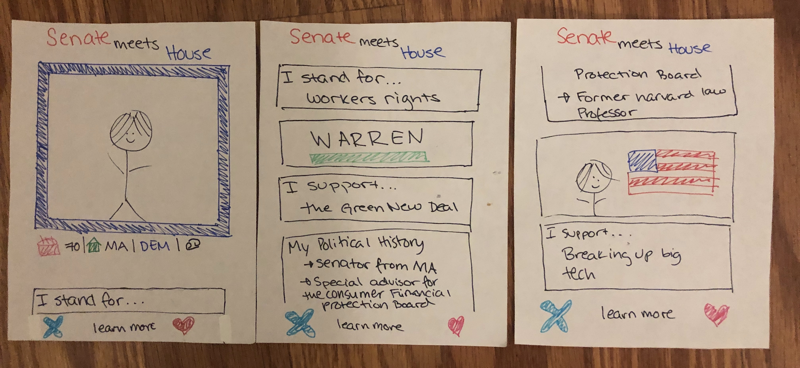

We gave users the ability to “swipe” left or right on certain politicians, in a manner similar to a mobile dating application. The example profile we created was of Elizabeth Warren, who is currently a Massachusetts senator and a democratic presidential candidate. Her profile consisted of her picture, her party, title, political voting record, as well as a selection of policies she strongly supports. We guided participants to look at Warren’s profile and then decide if they wanted to “match” with her or not. The prototype was designed to add an element of fun to political education. We hoped to achieve that by flipping the structure of dating apps to include political candidates instead of romantic partners.

When participants first saw and interacted with the prototype they were amused and delighted. They all immediately understood the layout and purpose of the prototype. Participants were eager to engage and even asked us more questions about Warren’s policy proposals. However, some participants pointed out that the “dating-app” format is not directly applicable because the politician cannot “swipe back” on you. That means that there are no real “matches” between politicians and voters. Additionally, participants told us that while it was an interesting idea, they are not sure how seriously they would take the information presented on the profiles. This showed us that while people do want politics more fun, trustworthiness and legitimacy of information is also top of mind for our participants. There needs to be a balance between entertainment and genuine education.

# PROTOTYPE TWO: WHAT POLICIES AFFECT YOU?

We tried to address the problem that people, especially younger or newer voters, have regarding not knowing their federal and local representatives nor the policies enacted in their district and state, or upcoming bills being voted on -- specifically regarding issues that they feel passionately about. We assumed that people would find this information useful on a fairly regular basis, but particularly before a voting cycle. We also assumed that many young people do not know this information, and that they would want to keep informed on the policies that may affect them.

For this prototype, we simulated an app or website with a Google form, that requested basic information from the user (email, address) and their political interests (healthcare, education, etc). The role of the participant would be to play this part of an interested, but uninformed voter, and fill out the survey. In this case, the participants were UC Berkeley PhD students.

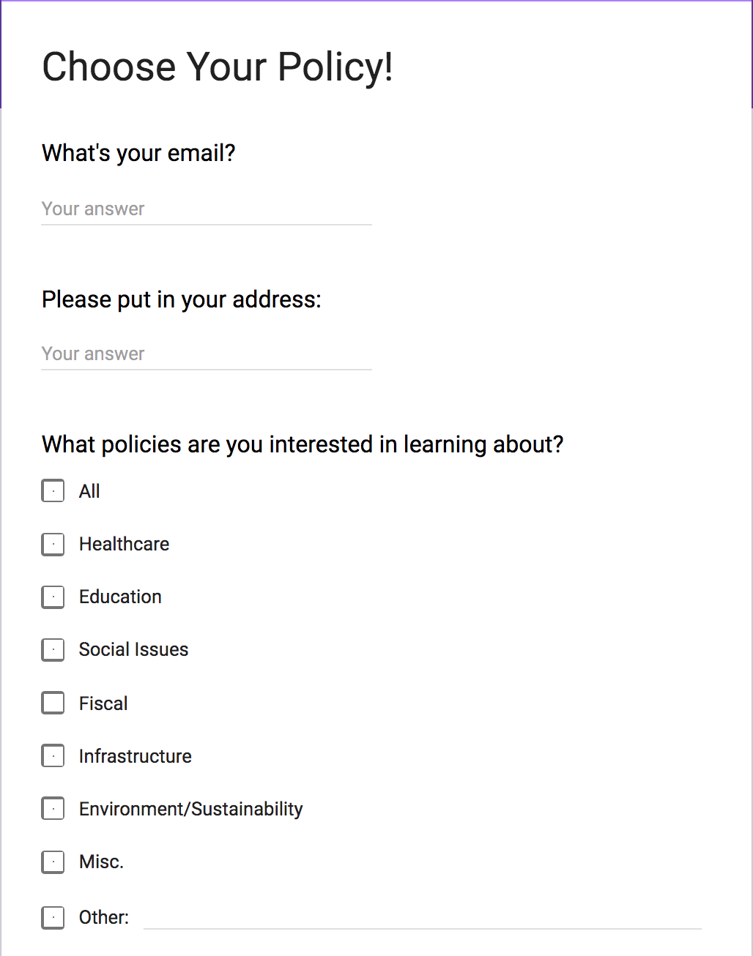

We sent this out to the participants, and afterwards, they received an email report compiling the information they asked for.

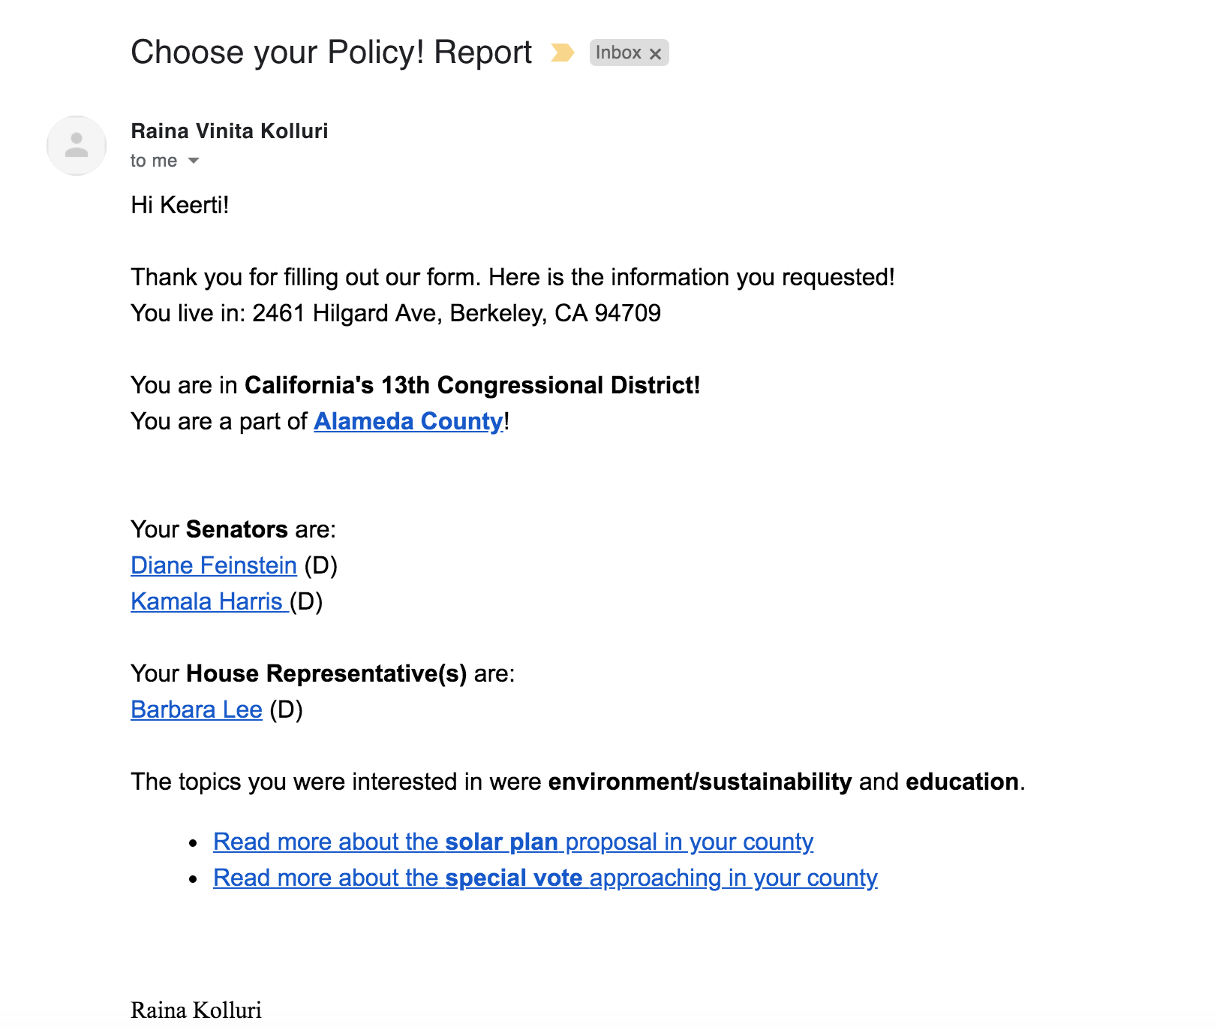

The participants generally enjoyed the prototype, because they only had a few steps to complete before they received the information that they wanted. The easy access of the information and links that the report directed them to were helpful. However, one participant expressed a wish for more granularity with the topics (ex. “social issues” is a broad generalization). While it’s informative for those less familiar with their local politics, it was hard for participants to imagine their peers using this service for fun or out of the blue for continuous interaction.

From this, we learned that this assumption that people are willing to learn about politics is generally incorrect. There has to be a special factor towards our prototype that encourages people to engage. Despite the information being helpful, it is generally irrelevant to those who don’t wish to learn.

# PROTOTYPE THREE: DUOLINGO APPROACH

In this prototype, we wanted to take another approach to making politics fun and fast for Gen Z. To do so, we borrowed from the popular language-learning application Duolingo, which uses quizzes and gamification techniques to hook users into learning a new language in under thirty minutes a day. Here we wanted to test the time constraint our Gen Z participants were complaining about. We wanted to test the assumption that if people could get educated in less time they would be more interested in politics.

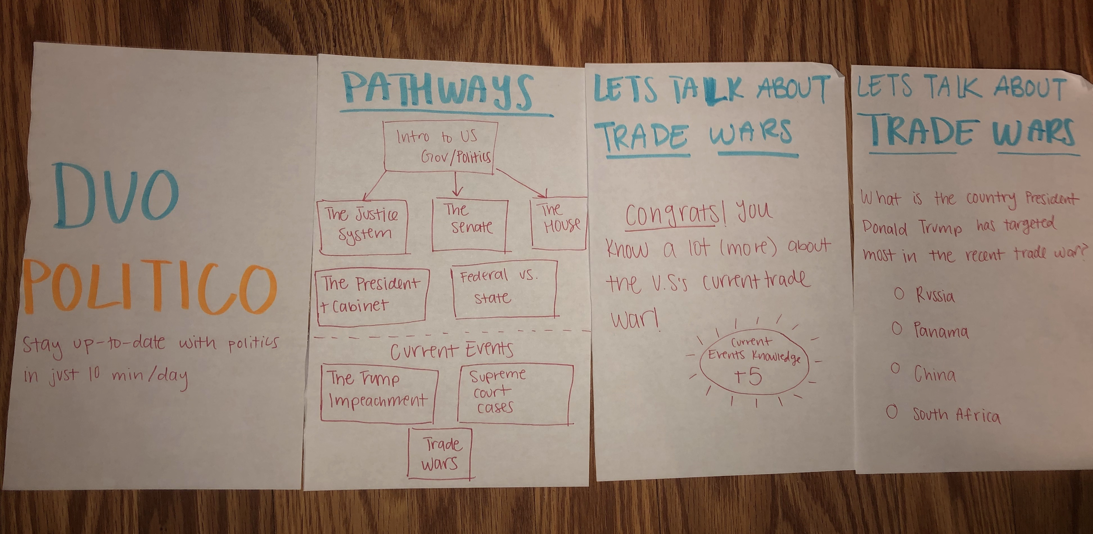

We constructed a basic paper prototype that allowed participants to select a topic area of interest. The participants were high schoolers from Palo Alto High School. We then verbally gave the participants a brief overview of the topic as well as links to several, fact-based news articles about the topic. Then we asked participants a series of simple questions about the topic they selected. They were rewarded fictitious “knowledge points” for getting answering a question correctly.

While the participants were generally engaged in the activity, afterwards most told us that they would not use it regularly. They said it requires a lot of initiative to willingly take a test, no matter how difficult. They told us that keeping up with their social media feeds already feels overwhelming, and a quiz-based application is not enticing.

# KEY TAKEAWAYS

This week was an extremely useful learning experience for our team. We were able to narrow down the scope of our project and started building genuine solutions to the problems we identified. Most importantly though, we learned more about the habits and needs of our users. First, we learned that people who are not significantly politically engaged are not willing to spend more than several minutes learning about politics each day. Second, we learned that people want a balance between entertainment and content. A platform that is purely educational was not appealing, but users also worried about the utility of a “gamified” political application. Finally, we learned that users enjoy when they are receiving political news relevant to their interests. This realization is more broad and will be useful in designing the “news choosing algorithm” aspect of our final project.

Out of all the prototypes we came up with, we achieved the best results with “Senate Meets House.” Many participants, with varying degrees of interest in politics, found the idea creative and delightful, but also informative. Relative to the other prototypes, “Senate Meets House” appealed the most to our target audience of young voters. However, we would like to refine it even further. We are excited to iterate and improve it over the next few weeks.